**📝 Tasks on NumPy Arrays**

**Task 1: Student Grades Analysis**

* Create a **2D NumPy array** representing marks of 5 students in 4 subjects.
* Find:
  + Average marks per student
  + Highest marks in each subject
  + Index of student with the lowest total score
  + 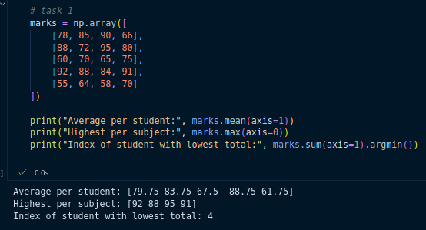

**Task 2: Image Reshaping**

* Create a **1D array of size 36** with values from 0–35.
* Reshape it into:
  + A 6×6 matrix
  + Then into a 3D array of shape (3, 3, 4)
* Print the shapes at each step.
* 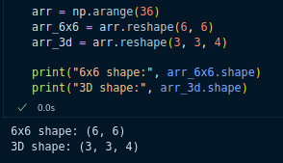

**Task 3: Random Data Simulation**

* Generate a **3×4 NumPy array of random integers (1–100)**.
* Sort each row individually.
* Insert a new column at the end with the **row sums**.

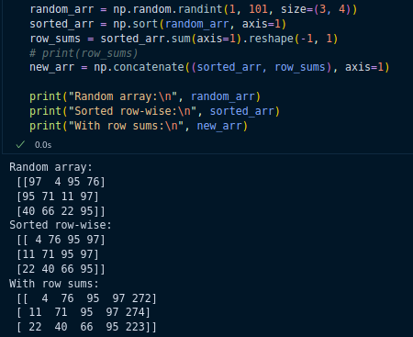

**Task 4: Splitting & Combining Data**

* Create a **1D array of numbers from 1 to 20**.
* Split it into 4 equal parts.
* Combine the 2nd and 4th parts into one array.
* 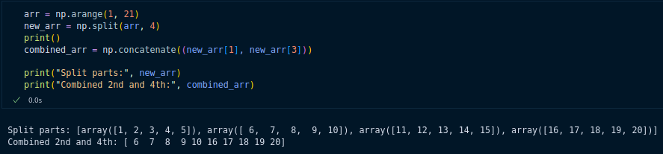

**Task 5: Data Cleaning with NumPy**

* Given an array:
* arr = np.array([12, -5, 0, 23, -15, 45, 30, -2])
* Remove all negative numbers.
* Insert the value 99 at index 2.
* Sort the final array in ascending order.

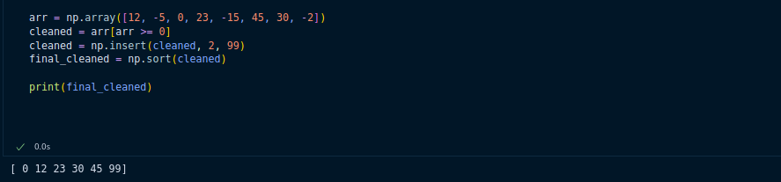

**Task 6: Stock Price Analysis (3D Array)**

* Create a **3D NumPy array of shape (2, 5, 3)** representing stock prices:
  + 2 companies
  + 5 days
  + 3 features: [Open, High, Close]
* Find:
  + Maximum closing price for each company
  + Day index when each company’s stock opened lowest

